**Factors directing spatial diversity and adaptation in halophilic desert microbiomes**

Gherman Uritskiy, Adam Munn, Micah Dailey, Diego Gelsinger, Samantha Getsin, Alfonso Davila, Peter McCullough, James Taylor, Jocelyne DiRuggiero

**Section 1: Introducing the scales of diversity**

To investigate the relationship of halite microbial community structure with abiotic factors, we conducted a robust sampling survey of the halite nodules in Salar Grande of Atacama, Chile. To address factors universally important for community assembly, community structure was interrogated across varying scales – ranging from major regions of the salar to micro-niches present within a single halite nodule.

|  |  |  |  |
| --- | --- | --- | --- |
| Scale | Distances | Distances |  |
| Large | Opposite sides of the salar | ~20km | Microbiomes subject to majorly different climates |
| Medium | Top and bottom of a hill | ~300m | Microbiomes subject to slightly different local climates |
| Small | Inter-halite differences in the same region | ~10m | Microbiomes in segregated and structurally unique nodules |
| Tiny | Intra-halite differences in the same nodule | ~10cm | Micro-niches in the same halite, subject to different conditions depending on position |

*Table: Overview of the study design looking into halite microbial community differences across different scales of community diversity.*

To address adaptation differences between halite communities subject to drastically different climate condition, we performed a wide sampling of the North and South ends of the Salar Grande in Atacama Desert, Chile. Samples were taken from 500m2 areas at each end of the salar, with 39 samples from SG1 (North) and 46 samples from SG2 (South). There regions were more than 19km apart, and were expected to have drastically different climate conditions due to the varying heights of the mountains that shield the salar from the ocean, and thus humidity.

To investigate adaptations of halite communities subject to much more similar, but still distinct conditions, samples were taken at the top and bottom of a prominent hill at SG1. The hill had 32m of elevation gain over 330m. 19 samples were taken from the top of the hill, and 12 from the bottom.

To look at communality differences between individual halites subject to similar external conditions, we performed a robust sampling of 6 halite nodules in a 10m2 area at the top of the SG1 hill. 6-9 replicates were sampled from each individual halite.

Finally, to look at community structure adaptations within different niches found within a single halite, we sampled 6 halite nodules in detail. The nodules were sliced with a saw in three locations, and in each slice samples were taken near the top, bottom, and middle of the halite. This sampling scheme allows us to interrogate community structure differences and similarities across the vertical and horizontal components, as well as correlate the structure to the distance to the nodule’s surface.

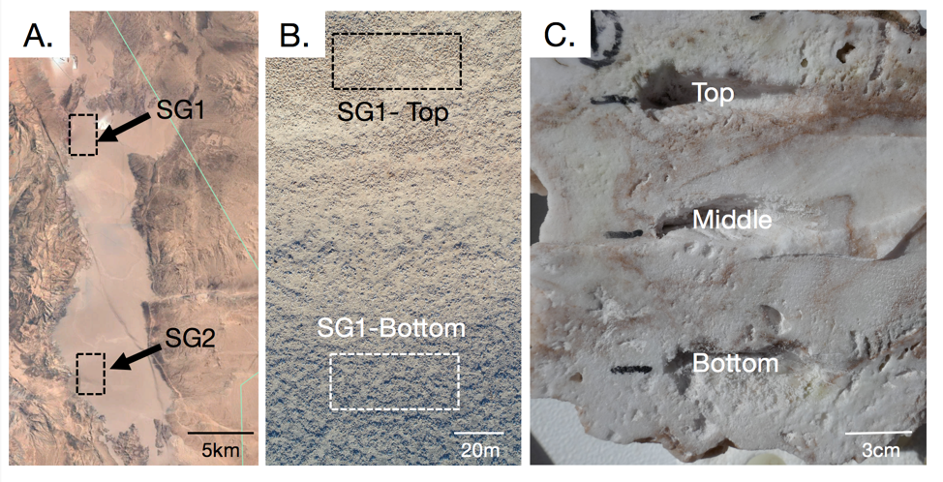

*Figure: (A) Google Earth view of the entire Salar Grande flat, highlighting the sampling regions named SG1 and SG2. (B) A top-down drone image of the slope of the hill at SG1, showing the sampling areas at the top and bottom of the hill. (C) A cross-section of a model halite nodule, showing the locations of samples taken from the top, middle and bottom of the nodule in respect to its original orientation in the field.*

**Section 2: Factors influencing halite communities**

To determine differences in climate conditions between the samples locations, HOBO weather probes were left for prolonged periods of time (3-15 months) to record relative humidity and temperature. Data was collected at SG2, as well as the top and bottom of the hill at SG1.

Micro-climate measurements were also taken inside a selected model halite at the top of the SG1 hill. Probes in the top, center, and bottom of the halite recorded humidity and temperature over the course of 3 months, and were contrasted with corresponding measurements made outside the halite.



*Figure: Climate data comparisons for large (SG1 vs SG2; A-C) and medium (top vs bottom of SG1, D-F) scales. Weather measurements were collected simultaneously at the two compared sites, showing differences in temperature (A, D) and relative humidity (B, E) of the locations. Colors denote the time (hours after midnight) of data collection for each point. The number of hours in the day when halites experienced deliquescence was estimated from the time when the relative humidity was above 75% (C, F). Paired weather data was collected hourly from 2018-03-01 to 2018-03-31 with a HOBO probe located 1m above the ground.*



*Figure: Temperature (A) and relative humidity (B) fluctuations at SG1-Top over an average day. Data was simultaneously collected 1m above the ground (“Air”) and with HOBO probes sealed inside a halite near the top, middle, and bottom of the nodule. Highlight lines represent the moving average of the data over 100 data points. Weather data was collected every 5 minutes from 2018-03-01 to 2018-03-31.*

To investigate differences in halite topology across the larger scales, measurements were taken comparing the halite density at SG2 and the top and bottom of SG1. 

*Figure: Distribution of halite nodules across the surface of different locations in Salar Grande. The relative distribution percentage was estimated from 6 randomized 100m transects, along salt formations were classified according stages of nodule formation, from a flat polygon to a mature halite nodule.*

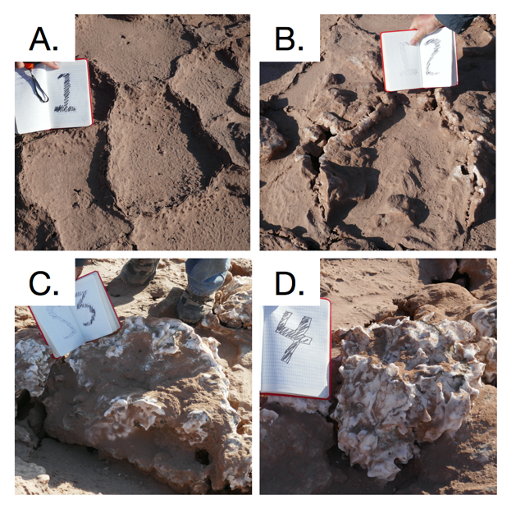

*Figure: Example photos of the stages of halite nodule development: a flat polygon (A), a rising polygon (B), a halite nodule (C), a fully mature halite nodule (D). 20cm notebook shown for scale.*

To investigate levels of available light for photosynthesis within the halites, we used a handheld fiber optic spectrometer to measure spectra transmission at different positions within the halites. From the underside of the halite nodule, a hole was drilled to a specific depth corresponding to a particular distance from the illuminated (top) surface of the halite nodule. A fiber optic probe was inserted into the hole. Due to the practical difficulties of operating the spectrometer and the drill in the field, the measurements were instead obtained in the lab, using a 500W broad-spectrum halogen lamp positioned 44 cm above the halites to simulate the solar illumination. The lamp’s spectrum was measured and used for normalization of the data to obtain the effective transmission inside the halite, thus nullifying any major differences between the spectra from the lamp and the sun. We used a cosine-corrector (translucent screen that scatters light but does not affect the spectrum) to homogenize the fiber optic cable’s angular response. For the bottom positions within the halites, we found that our direct transmission measurements in the lab could not reproduce realistic conditions from the desert. In the field, light scatters around and even underneath the halite nodules, which it not practical to reproduce in laboratory conditions.



*Figure: Effective light transmission inside halite nodules, measured 10mm from the top surface and in the center of the nodule. The center positions were taken to be the middle of the three halites, 30mm, 20mm, and 38mm from the surface, respectively. The transmission spectra of each halite were normalized to the mean transmission from the top position to bring out the top-middle differences over the inter-nodule differences.*

**Section 3: Phyla relative abundances**

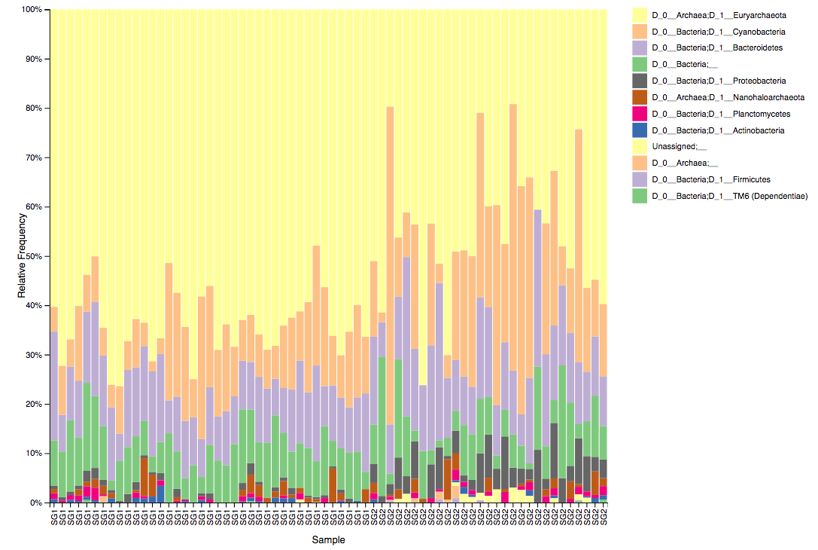

*Relative taxonomy composition of SG1 and SG2 locations at the D3 (class level). Cyanobacteria are significantly more abundant in SG1, while Proteobacteria were more [relative] abundant in SG2 (ANCOM, W=10). At the domain level, Archaea was significantly more [relative] abundant in SG1 (ANCOM, W=2). Interestingly, no significantly differential taxa were detected at the ASV (amplicon sequence variant) level.*





*Relative taxonomy composition of halite communities at the top and bottom of the SG1 hill in 2016 at the phylum level. Nanohaloarchaea, Proteobacteria, and Actinobacteria were found to be significantly more abundant at the top of the hill than the bottom (ANCOM W=6,9,8, respectively), and Cyanobacteria was more abundant at the bottom of the hill (ANCOM W=7).*





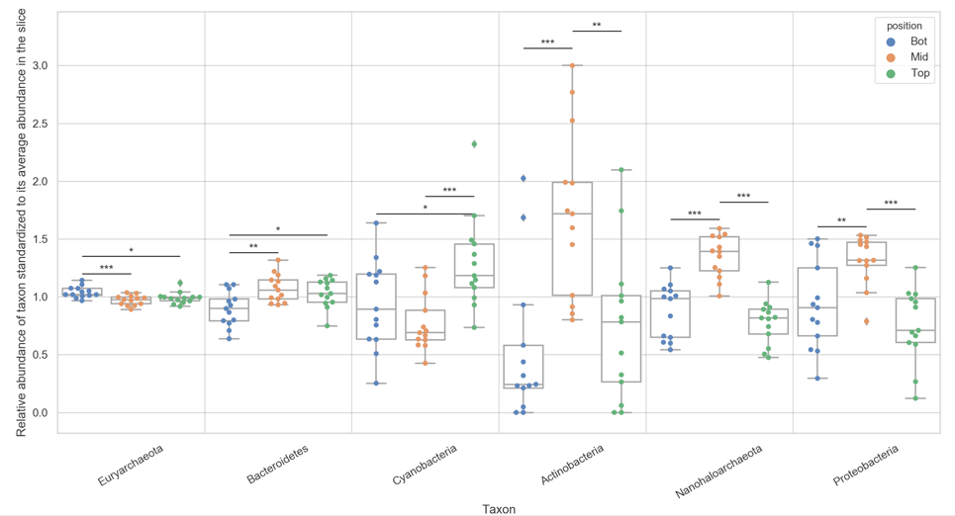

**Section 4: Taxonomic structure differences**

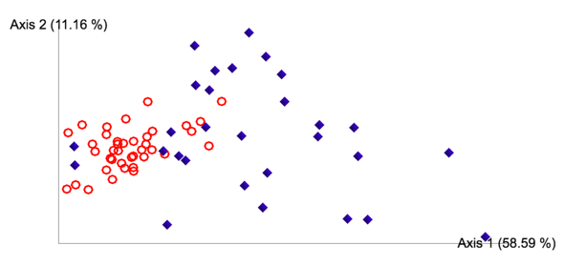

*PCoA of weighted Unifrac dissimilarity matrix of 16S rDNA amplicon sequences from SG1 (red rings) and SG2 (blue diamonds). Difference is significant (PERMANOVA: pval<0.001, test statistic= 28.36).*



*PCoA of weighted Unifrac dissimilarity matrix of 16S rDNA amplicon sequences from the top (blue diamonds) and bottom (red squares) of a hill at the SG1 location. Data collected in Feb 2016. Difference is significant (PERMANOVA: pval=* 0.001*, test statistic= 22.5).*

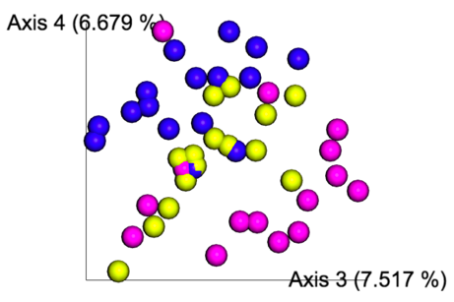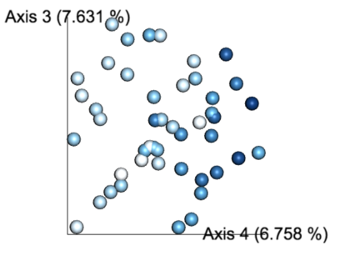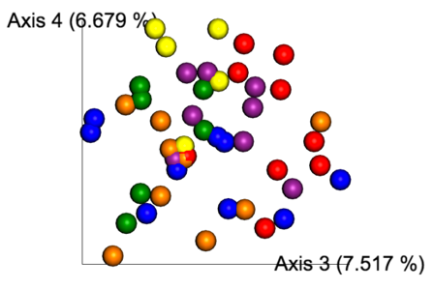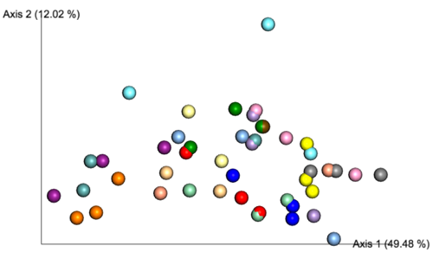

*A: PCoA of Weighted Unifrac dissimilarity matrix of samples collected at different position in the rock, showing composition differences between the top (yellow), middle (blue), and bottom (magenta) of the nodules, revealing a significant signal (PERMANOVA: pval<0.013, test statistic=2.59). B: Same PCoA colored by the distance of sample to the surface (dark is far from surface). C: The same PCoA, but colored based on the halite nodule the sample came from, showing a significant signal (PERMANOVA: pval=0.012, test statistic=* 2.15*). D: The same PCoA but with the second and third principal components, showing significant separation based on the slice that the sample came from (PERMANOVA: pval<0.001, test statistic=* 2.77*)*



**Section 5: OTU diversity differences**

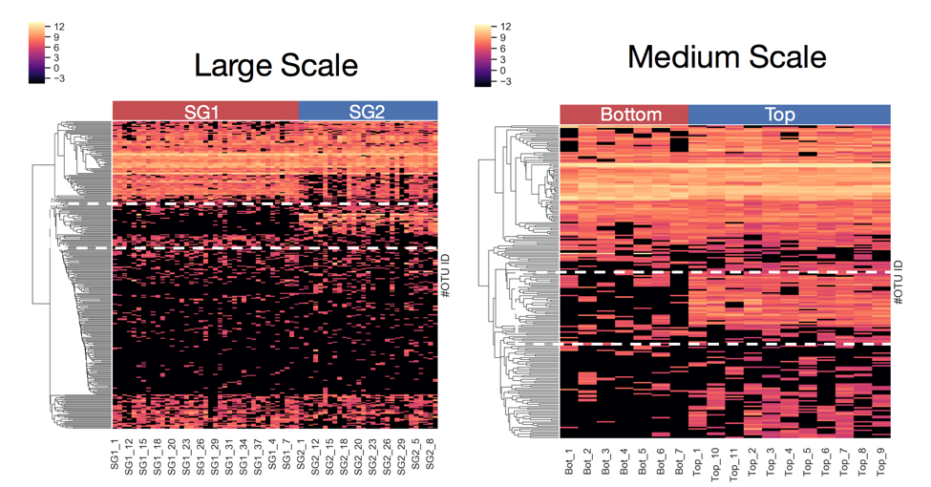

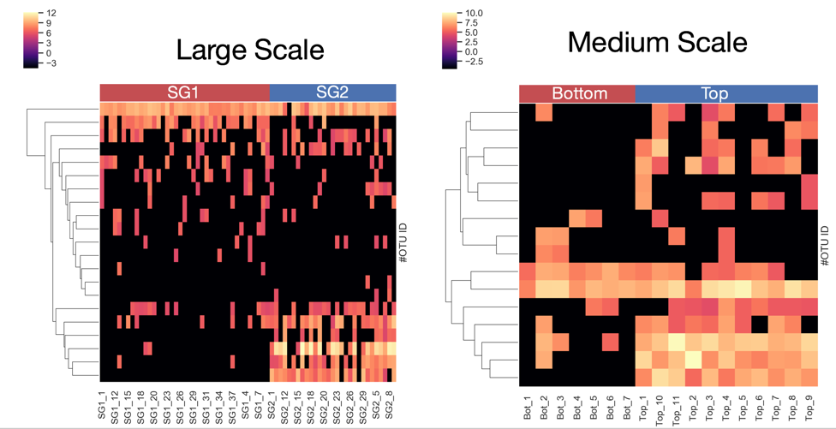



**Section 6: Biomass is independent from relative composition**



Conclusions

1. Small environmental parameter changes have large effects on community structure
2. Higher water availability permits more OTU-level diversity
3. Water availability affect relative abundance of major phyla
4. The more similar to locations are in conditions, the more similar the communities residing in them
5. Light availability influences Cyanobacteria relative abundance inside halites